**Reconfigurable Robot Inspired by Wheel Spiders: A Study of Wheel Spider’s Rolling Movements and its Application on Robots**

Lifan Yu

New York University Shanghai, Shanghai, China

**Abstract:** This project studies the rolling movement that wheel spiders employ under the threat of predators to quickly escape and current applications of this feature on robots. A bio-inspired robot is made to simulate such moving patterns.

**Keywords:** wheel spider, bio-inspired robotics, shape-shifting robots

# INTRODUCTION

“Wheel spiders” is a common name given to spiders that can both walk and roll with distinct postures, made possible by folding their legs in different ways. *Carparachne aureoflava* is a wheel spider species that resides on sandy hills. *Carparachne aureoflava* spiders can quickly escape predators by transforming into a wheel shape and roll down smooth sand dunes where they reside. They roll downhill with a speed of 0.5 to 1.5 meters per second, with a rotation rate of 10 to 44 times per second. Comparing to their speed of running, which is approximately 0.6 meters per second, rolling is much a much faster way of travelling in obstacle-deficient areas (Henschel, 1990).

When walking, their legs are stretched out like normal spiders. When rolling, their legs are folded, forming a round shape.

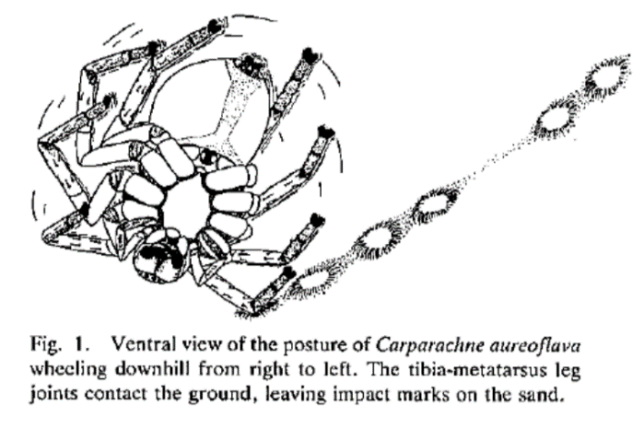

The rolling behavior of *Carparachne aureoflava* might be due to a result of their living environment which is abundant in slopes and deficient in obstacles.

However, other wheel spider species also feature rolling movements. Some can roll on flat surfaces as well. By kicking their legs on one side, they move forward while rotating in the air. When they fall back onto the ground, they roll or kick again to facilitate the next iteration of rotation. The folding and unfolding of legs enable wheel spiders to roll quickly. Below is an image of *Cebrennus Rechenberg* (Moroccan flic-flac spider).

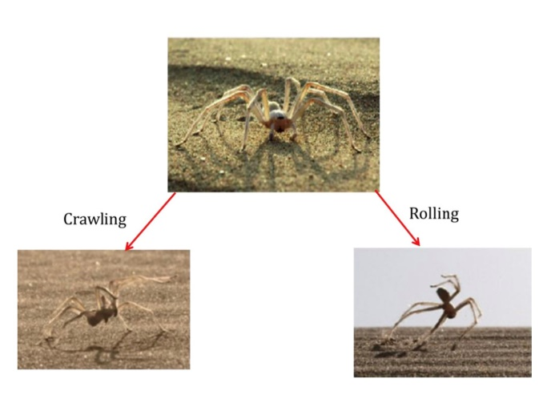

Generally, such spiders employ locomotion

By forming an “abstract wheel” with its legs. This wheel shape isn’t “mounted on”, neither is it “spinning around a fixed axle”. The whole structure rotates by reconfiguration. Therefore, a bio-mimic robot

Through observations of wheel spiders’ movements, an inspiration was drawn that robots, especially those with arms and/or legs, can also adapt such a configuration so that they can shape-shift into a cylinder and travel quickly in smooth surfaces.

A robot that both imitates wheel spiders in shape and in motion is designed. It is a shape-shifting robot with four curved legs and a cylinder body. The robot simulates the wheel spider’s motions. It is designed to use legs to move under normal circumstances and roll across the ground in a cylinder configuration under other conditions.

# METHODOLOGY

Three prototypes were made.

**2.1 The first prototype**

The first prototype was a cardboard prototype with only four servo motors that enabled the rolling movement.

Inspired by already-existing wheel-spider-inspired robots as in the case study of Kapilavai in 2015, as shown below.

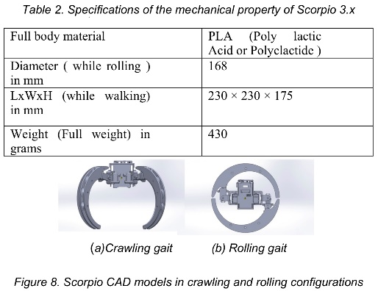

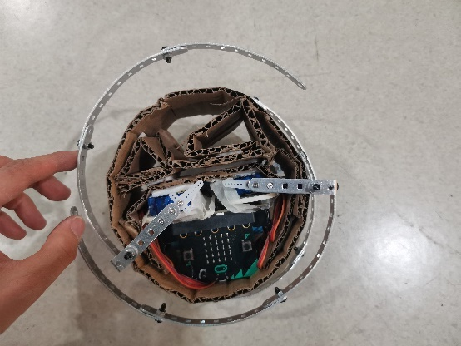

In this configuration, its legs are folded as shown below, which prevents it from switching to a walking position.

**2.2 The second prototype**

If there were 12 servos, the walking-rolling process could be made possible, as shown in the images below from Kapilavai’s report.

In each leg, a servo that connects the leg and the body enables the leg’s horizontal movements, allowing each leg to move to a forward direction or a sideways one. The middle servo enables vertical movement of the leg’s lower part, enabling the robot to lift its leg and pace forward. The last servo controls the folding of the curved part to form a wheel shape.

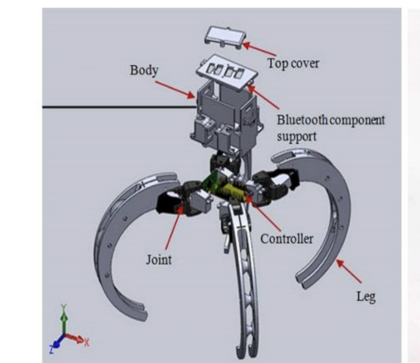

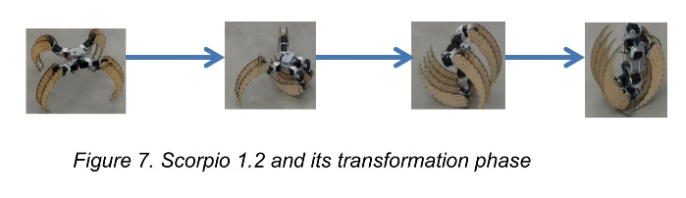

In the second prototype, the walking problem was solved by applying another configuration inspired by the one above. Additionally, a 3D printed rim was mounted.

Bent aluminum pieces were used to form the

curved parts of the four legs.

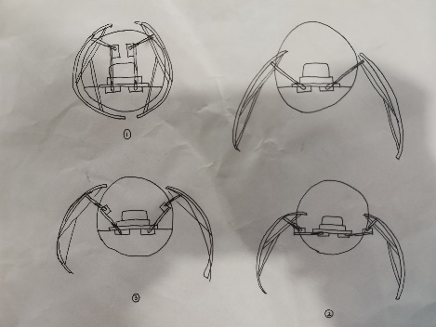

As aluminum pieces were gradually added to the structure, It became obvious that eight servos are also able to complete the rotation. However, because the servo controlling horizontal direction is missing in each leg, the robot can only move sideways, not forward and backwards. The aluminum pieces took a triangular strengthening structure to maintain the shape.

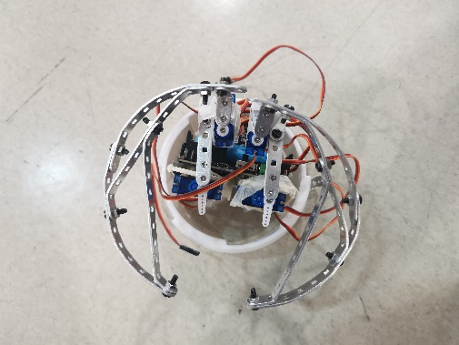

All servos were mounted using hot glue, creating a relatively stable structure. In this stage, it was already able to roll forward and backwards.

Problems with this prototype were that its center of gravity isn’t located in the middle, additionally, the 3D printed model is a rim of a sphere. It was wider in the middle and narrower on the rims. Therefore, the robot tilted to left and right when rolling. Moreover, the diameter of wheels and the body did not match, adding to the instability.

**2.3 The third prototype and programming**

The third prototype then became the final prototype, with 3D printed body, which was an almost-standard cylinder, and legs made from half rims of the 3D model used as body in the last prototype. The mounting style of outer servos were reconfigured, pressed against bent aluminum pieces, allowing a stabler movement.

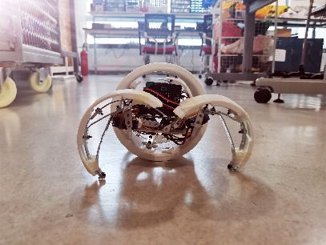

One of the moving patterns of the robot is in the code below. In the tumble function, it uses two legs on the same side to push the ground and rolls. The two legs on the other side then folds back after a short interval of milliseconds, allowing the momentum to drive it forward. The count measures each unit movement, After a certain time, when the sensor on top senses no obstacles, meaning that the spider is in a start-up position, the stand() function is called. It then stands up with all four legs.

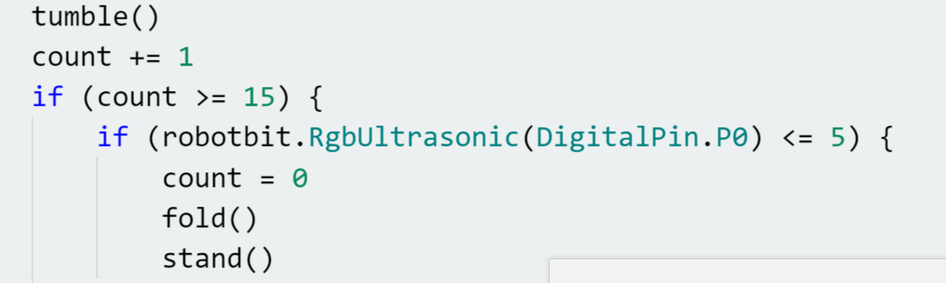

In arranging the unit movements and the movements’ functions, an additional prototype (a very simple one) was created to determine the angles.

To maximize the usage of each servo’s range of rotation, all servos were programmed to turn to an angle of 90 degrees, with the attached aluminum pieces facing towards the middle of the rotation’s range. It also standardizes each servo’s angle and facilitates further programming because by observation, the angles would be obvious. As shown below:

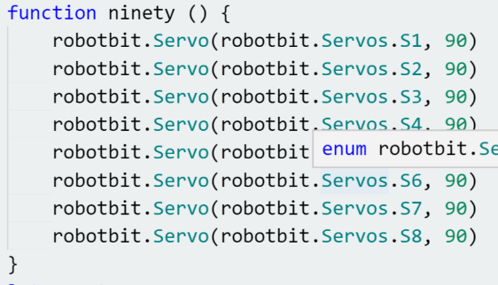

A function that determines whether the robot is in upright position.

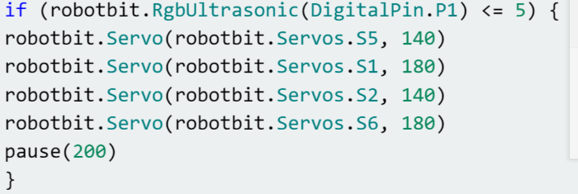

The most basic unit movement: tumble:

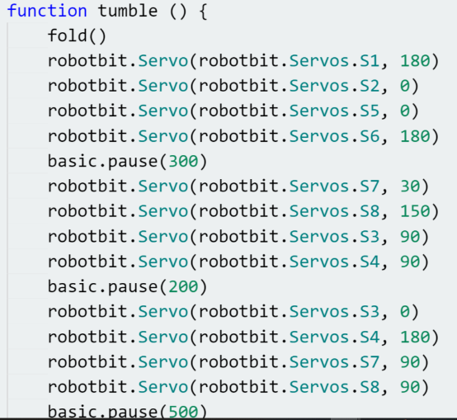

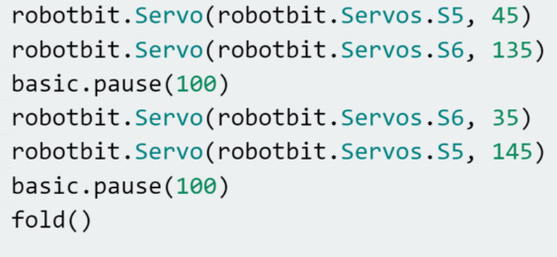

Another unit movement, fold, which forms a cylinder:

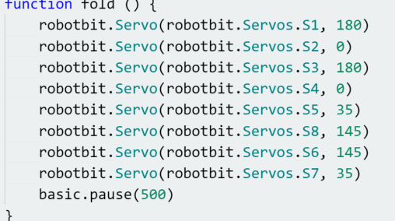

The movement that allows the robot to stand on its four legs:

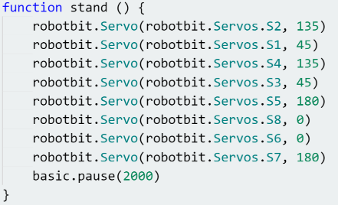

Final product:

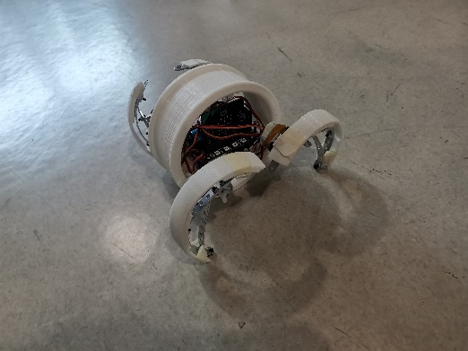

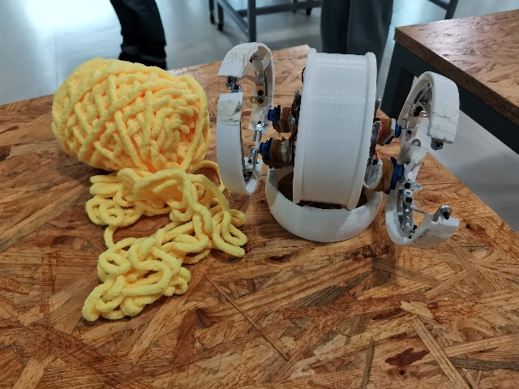

# RESULTS

In the final presentation, the robot was able to stand up, fold and unfold itself, and roll successfully across smooth surfaces using different patterns.

In testing stage, sensors were mounted. An ultrasonic sensor was attached in the lower hemisphere, facing down and detecting the distance between its main body and the ground,

On the upper hemisphere, I attached an infrared sensor to sense whether there are outer obstacles or whether it is upside-down.

On the lower hemisphere, I attached an ultrasonic sensor to detect its distance to the ground to test its position compared to the ground, so that it knows when to perform the next movements.

These sensors, adding to the weight and disturbing the center of gravity, were eventually taken off, and needed further adjustments.

# DISCUSSION

**4.1 Possible real-life applications**

A possible application of the reconfigurable robot can be for rescue purposes, For different landscapes, narrow places, or flat surfaces, etc. They transform into a rolling configuration and travel quickly, and retransform to normal mode to perform tasks.

Also, some spherical robots are already produced by companies serving as household robots.

**4.2 Further Improvements**

In nature, the spider can transform to a rolling configuration without having a “start-up” gesture. It rolls instantly (Kapilavai, 2015). Our robot, if not arranged in an upright starting position, would not roll as effectively. There can be a function added to automatically turn the robot to a starting position, or, create another “tumble()” function that allows immediate rotation in all starting positions.

Additionally, more sensor inputs could be added to the spider robot to imitate real-life spiders that uses their eyes and furs to sense the environment around.

The normal servos were not able to effectively support the robot’s weight. Stronger metal servos are needed if the robot is to walk and roll more effectively.

Servo mounts were not ye 3D designed and printed due to time limitations. If there had been servo mounts, the servos would have stayed stable and performed movements with more strength as well as stability.

# 5.REFERENCE

Henschel, Joh R. “Spiders Wheel to Escape.” *South Africa Journal of Science*, vol. 86, Mar. 1990, pp. 151–152.

Kapilavai, Adiya, et al. “Bioinspired Design: A Case Study of Reconfigurable Crawling-Rolling Robot.” International Conference on Engineering Design, 27 July 2015.

Miura, Takeshi, Shoshiro Hatakeyama, and Masami Iwase. Development of Wheel-Spider-Inspired Hexapod Robot Realizing Walking and Rolling Locomotion. The Institute of Electrical and Electronics Engineers, Inc. (IEEE), Piscataway, 2019.